Holiday cottage welcome book
Fill in your cottage details and replace the example image with your own. Check every instruction at the property. Share working access details privately with the intended guest.
[Cottage name] | Last checked [date]

Arrival
Address and postcode [verified address]
Check in [time and time zone]
Final approach [landmark and turning]
Parking [allocated spaces and route to keep clear]
Keys or lock [method and private delivery process]

Entrance photo
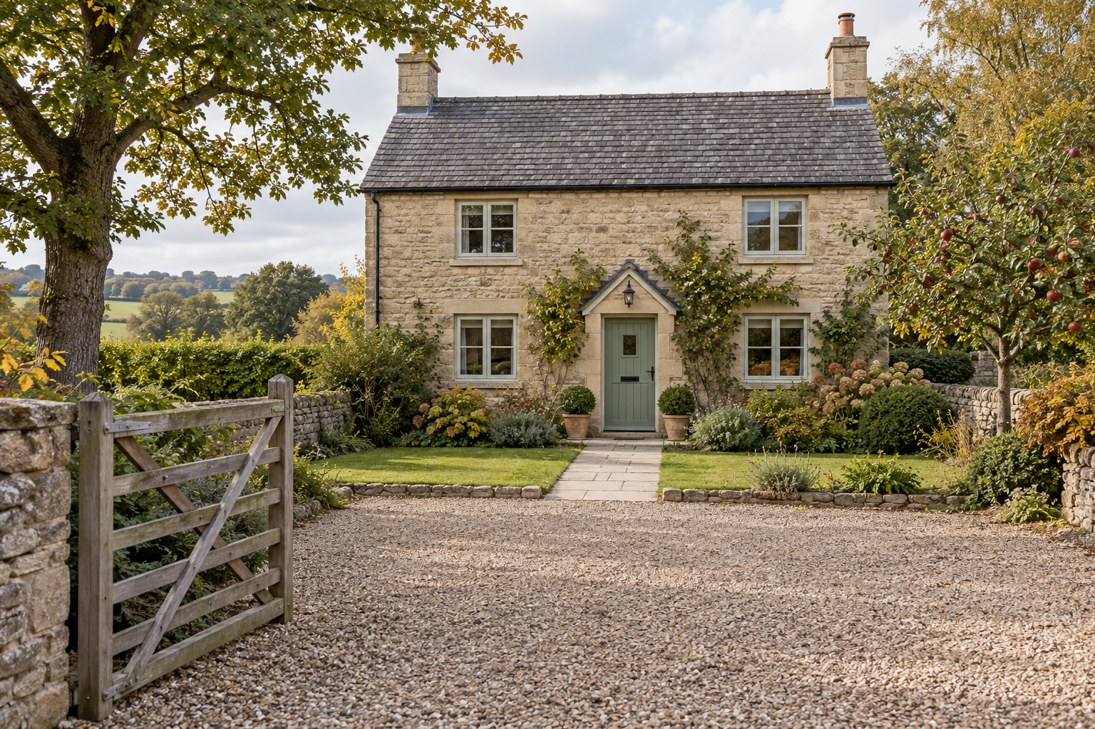
Fictional generated example. Replace with a photo of your actual entrance.

Wi Fi and arrival help
Wi Fi details [where the intended guest finds them]
Reception [verified limitations and what to save before travel]
Host contact [channel and support hours]
Arrival backup [agreed out of hours contact]

Using the house
Write short normal use steps beside each piece of equipment. Use the installed controls and the instructions that apply to your property.

Heating and hot water
Controls [location and photo]
Normal use [tested steps and expected behaviour]
Hot water [verified schedule or limitations]
Help [contact for a fault and controls reserved for the host]

Kitchen and laundry
Hob [normal use steps and photo]
Dishwasher [detergent location and cycle]
Washing machine [controls and supplies]

Special facilities
Available facilities [only those included in the booking]
Before use [property specific instructions and agreed restrictions]
If something is faulty [stop using it and contact the host]

Equipment photo
[Insert a close up of the installed thermostat or appliance controls]

House routines and departure

House and garden
Quiet hours [rules already agreed for the stay]
Pets and boundaries [agreed arrangements]
Gates [which gates to close and how]

Waste and local essentials
Bins [locations and sorting instructions]
Collection [verified arrangements]
Groceries [name and link to current opening hours]
Transport [checked contact or booking link]

Help
Host and backup [verified contact channels]
Urgent situations [local emergency information checked for the property]
Property address [address and approach landmark]

Check out
Leave by [time and time zone]
Agreed tasks [short list that matches the booking]
Equipment [verified departure settings]
Keys [return method]
Confirm departure [message channel]

